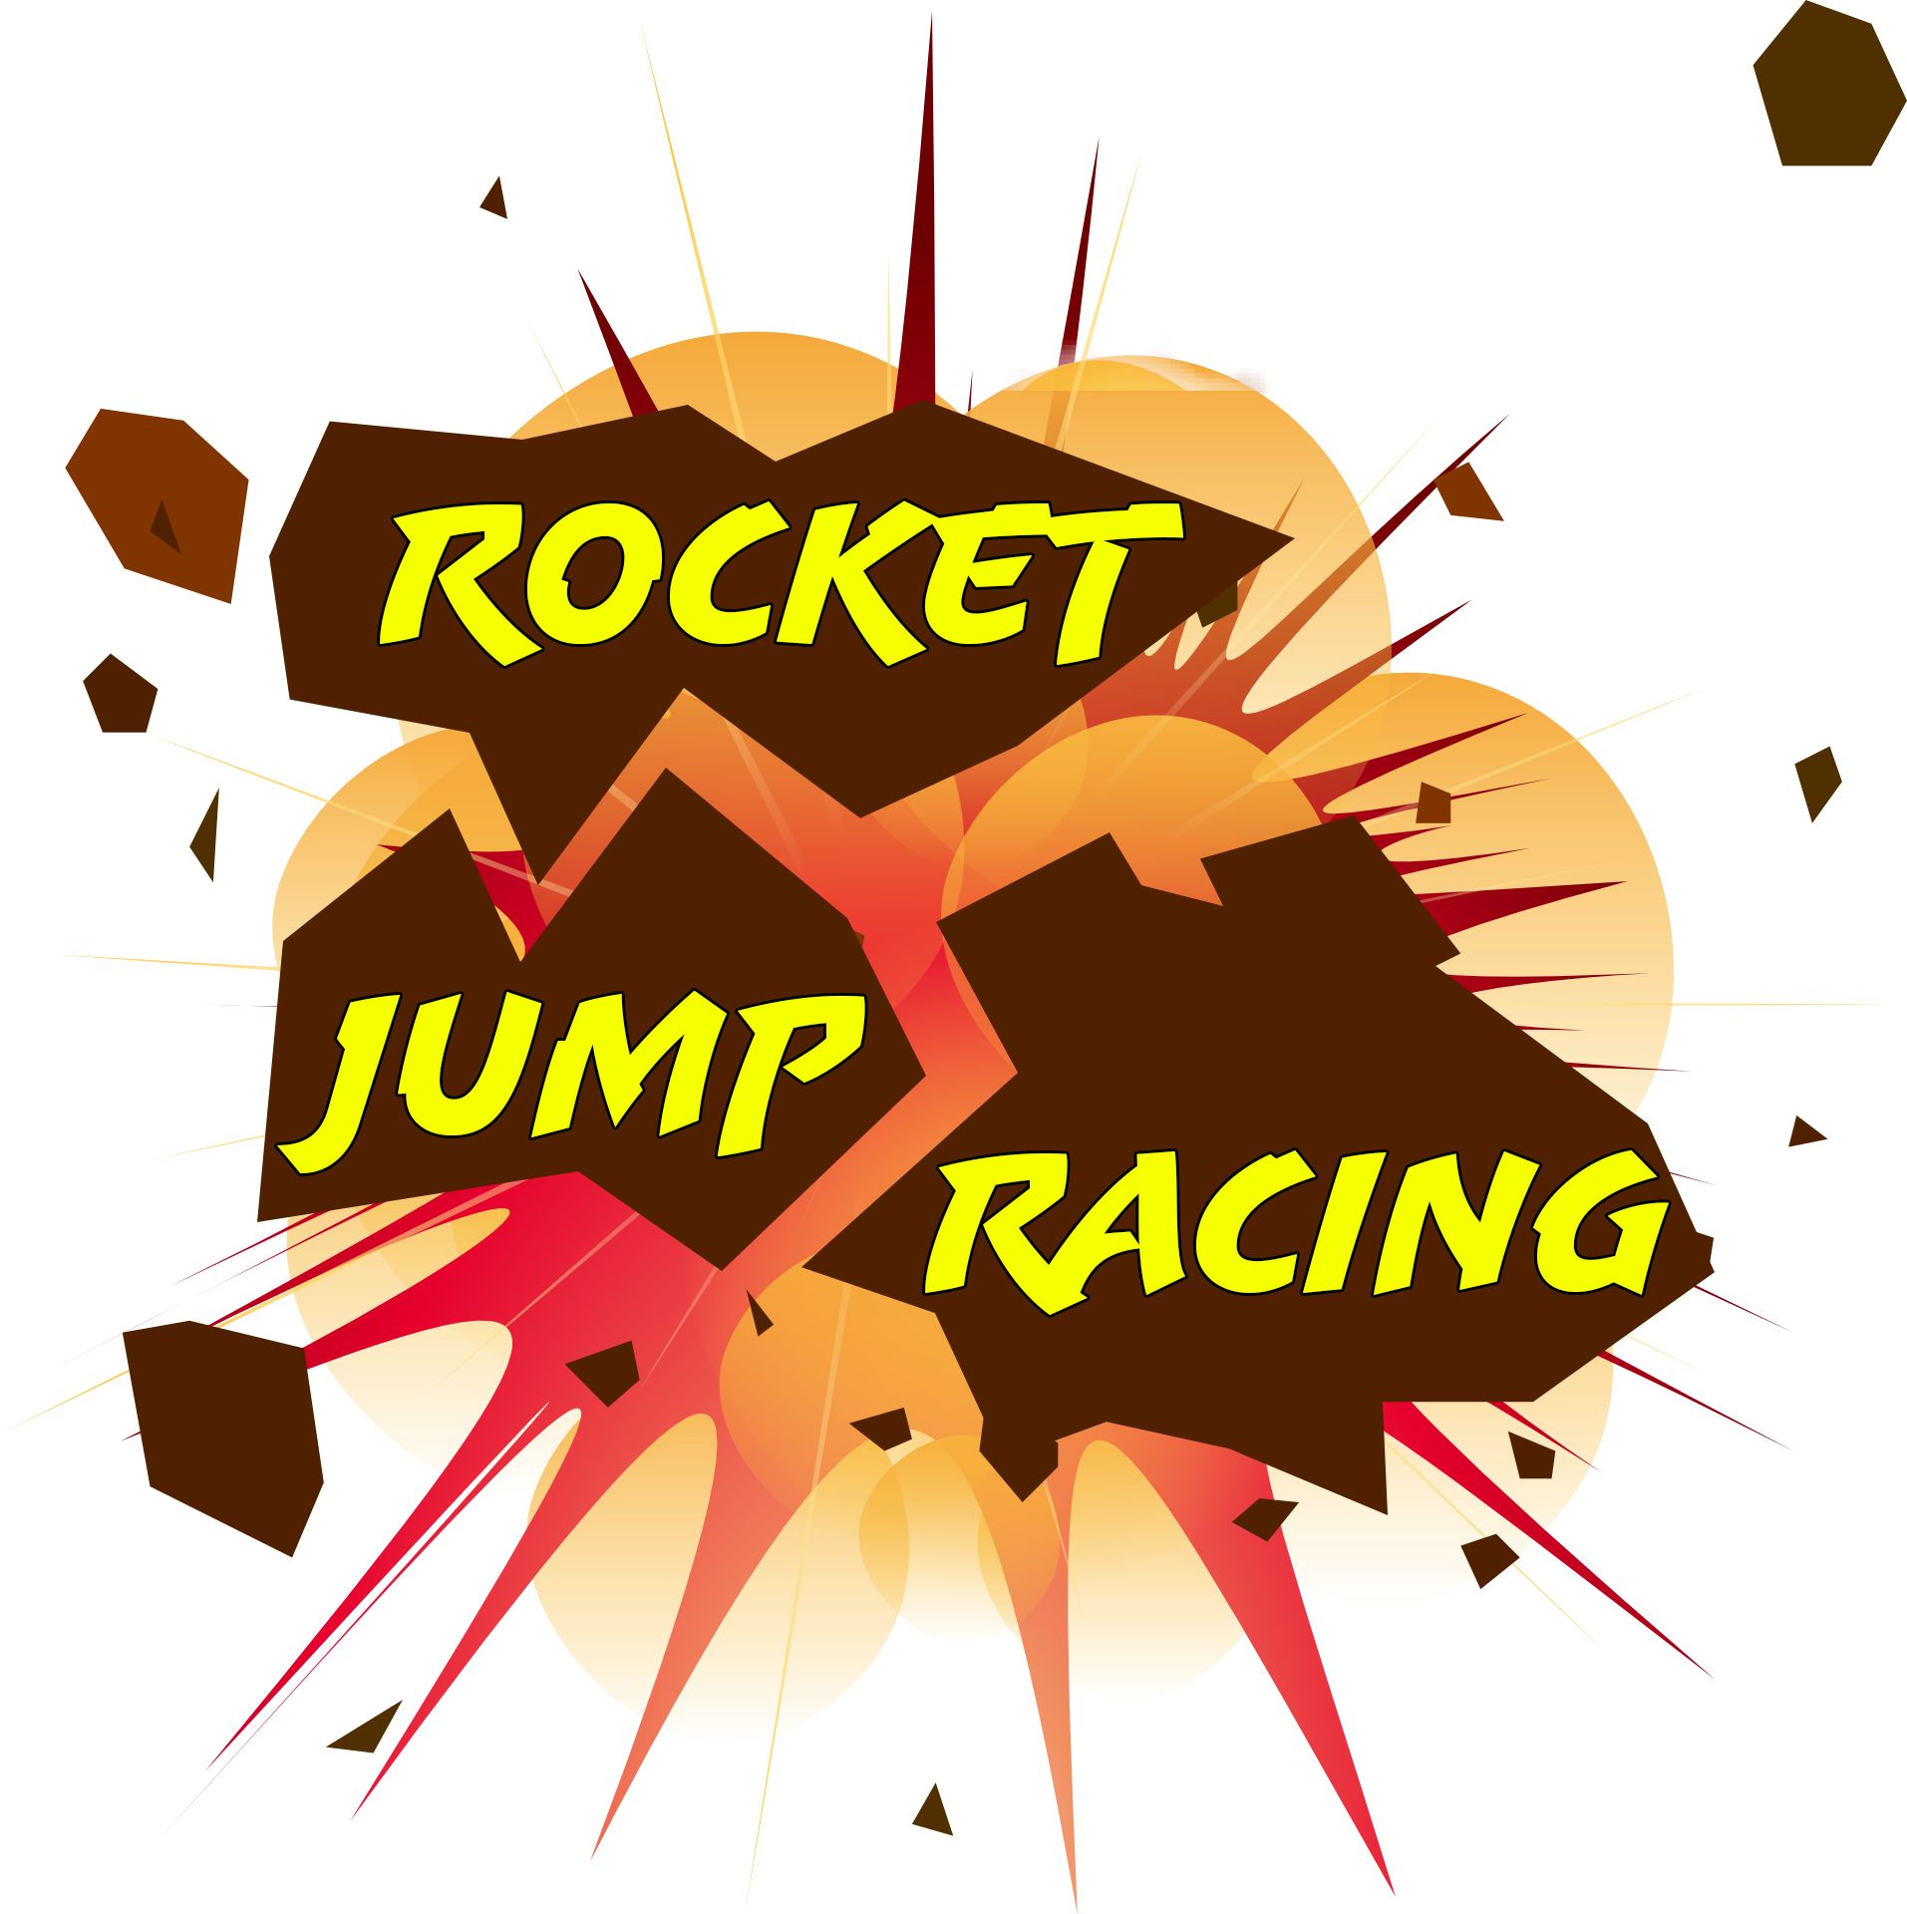

**Race Track 1   
*(use production name)***

Designer: <NAME>

Document Creation Date: 11/12/2020

**Level Finish Date: <DATE>**

Version: x.xx

Last Update Date: <DATE>

**Table of Contents**

**Level Layouts**

**Layout Elements Key**

**Gameplay**

**Game Narrative (Leading up to this Level)**

**Level Objectives**

**Level Narrative & Walkthrough**

**Mechanics Required to Complete Level**

**Previous to this Level**

**Learned in this level**

**Special Features**

**Look and Feel**

**General**

**Genre**

**Mood**

**Pacing**

**Environment** *(Each Unique Section requires the following)*

**Architecture**

**Materials**

**Color Composition**

**Lighting**

**Initial Visual Impacts**

**Music \ Sound \ Dialogue**

**Level Music**

**Sound and Music Inspirations**

**Ambient Sounds**

**Specific Sounds**

**Dialogue \ Voice Over**

**Asset Lists**

**Packages \ Sets**

**Unique Level Elements**

**Other Level elements**

**List of Elements Needed**

**Level Layouts**

The race track has a series of checkpoint nodes set at certain intervals throughout the track that will be used to help keep track of player positions, and set respawn points should a player go out of bounds on the map. The map also includes boosters set at various points that a player can use during certain times, synced up to the music of the level. The player will use these boosters as well as their inherent abilities to traverse both moving and stationary obstacles. The moving obstacles will also be synced to the music. There will also be power ups that a player can collect (maximum 1 power up at any time) and can use that power up when they see fit. The power ups will be placed in key locations, such as narrow strips of the map to help encourage a player to use that item in a proactive manner against other players.

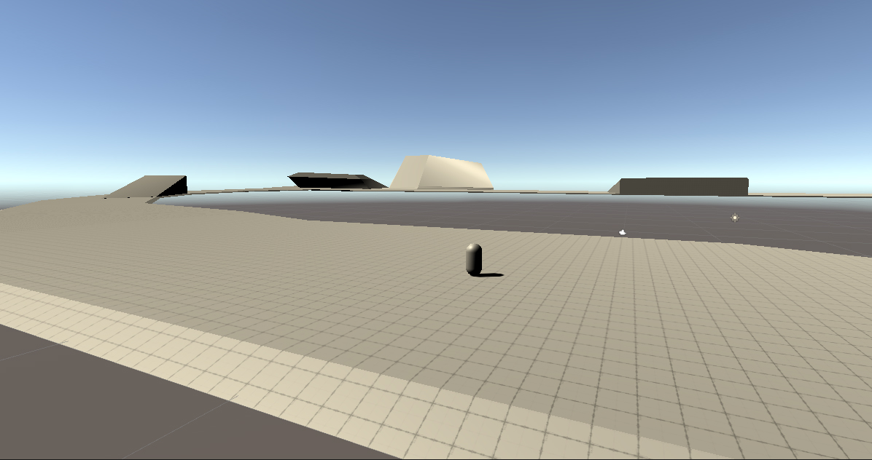

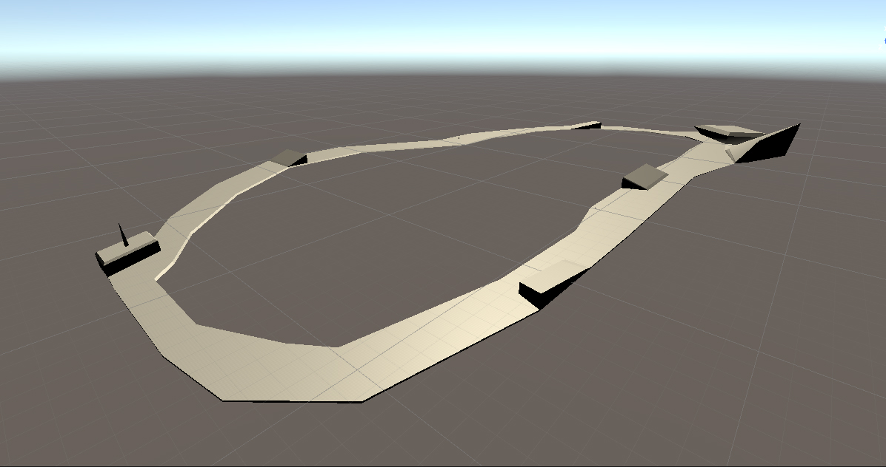

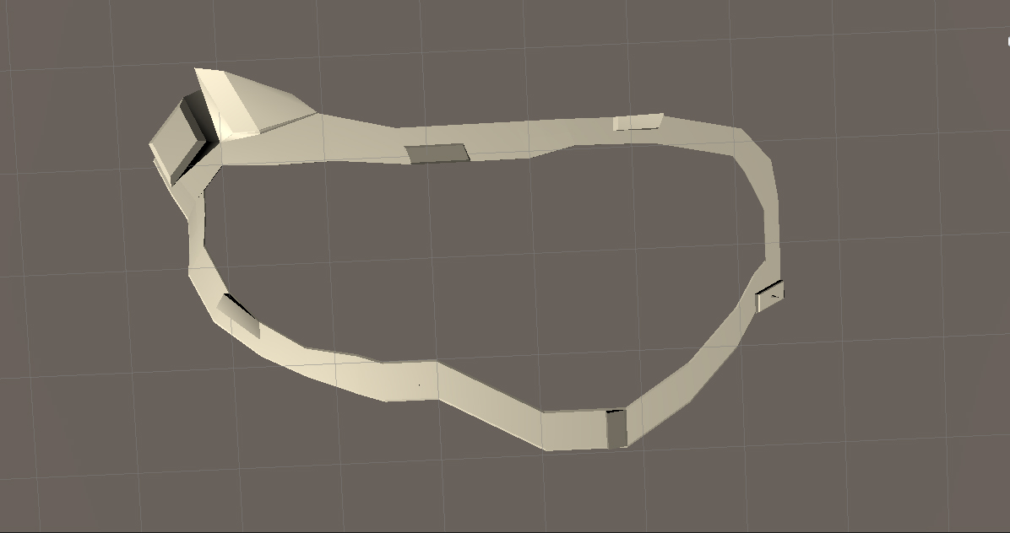

**Gameplay**

**Game Narrative:**

This is a race.

**Level Objectives:**

Win the race by placing first after 3 laps.

**Level Narrative:**

You are a racer for the RJR racing network. The group travels to various different planets that have racing tracks and races one another.

**Level Mechanics:**

There are boost pads and power ups that the player can use to gain and advantage over other players. The power ups are spread across various points in the map, and the boost parts are found close to the straight aways in the track. The boost pads as well as some obstacles are linked to the music playing in the level to encourage players to move at a specific pace.

**Look and Feel**

**General:**

The general look for the game is going to be a retro future sort of aesthetic.

**Genre:**

The genre for the game is a space sci-fi genre.

**Mood:**

In terms of mood, we’re going for more of a teen style sort of humor, while still being a lighthearted game that kids could play.

**Pacing:**

For the pacing of the game, the faster the better. We want players to be able to move very quickly, while still maintaining a sense of control both in the air and on the ground. After all, our primary game modes are based around being fast to avoid other players/ outposition other players to win.

**Environment**

**Architecture:**

For the architecture of our game, we are working more with very geometric shapes to keep in line with our Retro-Future aesthetic. For this, we mostly use shapes like spheres and cylinders to create a more smooth sort of shape for our buildings within a level.

**Materials:**

In terms of materials, most things are going to be built out of metallic materials, plastic materials, and some glass materials.

**Color Palette:**

Our color palette is going to be more of a bright, cheery version of city style neon lights. We also will include some more moderate colors, like whites and greys to help offset the overall brightness of the neon coloring.

**Lighting:**

As far as lighting goes, we want to have some lights, such as indicators for direction to be very distinct lights, while still working in a bright environment.

**Initial Visual Impacts:**

The biggest visual impacts should be the directional lights, and the race track itself. After that it will be the players within the race track as the next big visual impact.

**Music\Sound\Dialogue**

**Level Music:**

For the level music, we will be implementing a small selection of songs that promote the Retro-Future aesthetic, while still providing a healthy beat to help in setting up the music interaction within the level.

**Inspirations:**

For music inspirations, we’ll be looking at Motor Mayhem again for it’s more industrial sound, as well as some songs by Caravan Palace, Parov Stelar, Gorillaz, and Meganeko.

**Ambient Sounds:**

There will be very little to no ambient sounds outside of maybe some cheering from a crowd and a specific sound for the boost pad.

**Specific Sounds:**

For the sound design of the game, we will be implementing explosion sound effects for all characters, as well as footstep sound effects, impact sound effects, and various grunt noises to show the player being hit by something (such as a rocket) and/or landing/making an impact against something.

**Dialogue:**

We will most likely not be implementing dialogue for the game at this time.

**Assets**

* Boost Pad
* Power-ups
* Race Track
* Obstacles